Catcher Plans
This is a practice that can be done on the field as well as off. The goal is to obtain mental readiness so you can execute the plan without thinking after the ball is hit. Remember CPT:
Control – Am I in my ready position? Glove on, standing in right area…
Plan – What’s my play if I get the ball; plan the play before it happens, have a backup plan; if I drop the ball then what?
Trust – Trust! Trust that you will execute your plan because you’ve already gone over it in your head.
Mental Checklist
Run through this before every pitch.
- Control: Am I in my ready position?
- What is the strike count? Ask the umpire. Keep in mind drop 3rd strike.
- Where are my runners? Look at the bases and see the runners. Will I have to throw out a stealer?
- What's my plan? If I field the hit ball, a bunt may be yours, or a pop up foul ball.
- Trust!!! Trust that you can execute your plan, mistakes are a must because it means you tried!
NOTE: Always be ready to receive the ball, you never know when someone will run home, bunt, steal, or hit a pop up over your head.
RUNNERS ON | PLAN | BACKUP PLAN
None | Throw to 1B. | Get it back to the pitcher.
1st | Throw to 1B. | Get it back to the pitcher.
1st, 2nd | Throw to 3B if you are in that direction otherwise throw 1B. | Look for oncoming runner for the tag, else get it back to the pitcher.
1st, 2nd, 3rd | Touch home plate then throw 1B. | Look for oncoming runner for the tag, else get it back to the pitcher.
2nd | Throw to 1B. | Look for oncoming runner for the tag, else get it back to the pitcher.
2nd, 3rd | Throw to 1B. Be ready to get the ball back from 1st base to make a tag on oncoming runners. | Look for oncoming runner for the tag, else get it back to the pitcher.
1st, 3rd | Throw to 1B. Be ready to get the ball back from 1st base to make a tag on oncoming runners. | Look for oncoming runner for the tag, else get it back to the pitcher.

- Trust!

Mastering the easy outs is a good place to start since they take less strategy. Planning the play can be done on the field and off. As a mental exercise, you can run through plays with your child in the car, on the way home from school or at home for a few minutes. The more mental repetitions they have of thinking the play the chances are higher they will execute the play without thinking once presented with the situation.

Drop Third Strike
Drop 3rd strike is very important for a catcher to remember. If the ball touches the ground before you catch it and it's the batter's 3rd strike, that is a dropped third strike. Touches the ground can mean the pitcher pitches a ball that hits the ground before it even gets to you or a pitch thrown over your head. In short, it is important to try to catch the last strike on the batter. The last strike on the batter can be a pitched strike or a pitched ball (non-strike) that the batter swings at.
The batter can become a runner in the following situations:
- Any time there are two outs.
- Less than 2 outs and 1st base does not have a runner at it at the time of the pitch.
Planning your play is important to handle a drop third strike. Most of the time you will either tag the batter or throw to 1st base. If the bases are loaded, and there are 2 outs, all you have to do is touch home plate because home plate is a force out.
Stealers
As a catcher you must know where the runners are before every pitch. At this point don't try to get steal outs if there is a runner on 3rd base.

Steal to 2nd Base
Only in this picture will you ever throw to 2nd base. Do not throw to 2nd in any other situation!
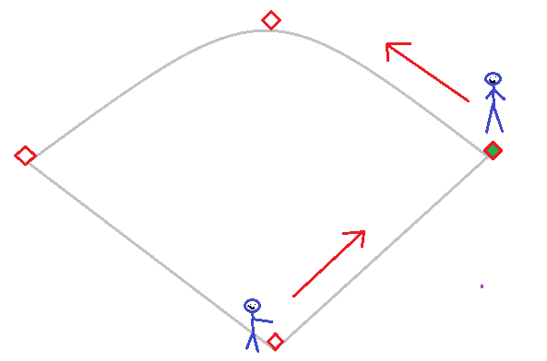
- Runner tries to runs to 2nd base throw down to 2nd.
- Runner has too far of a lead, throw to 1B. This won’t happen very often if ever.
Steal to 3rd Base
Only in these pictures will you throw to 3rd base for a 3rd base steal.
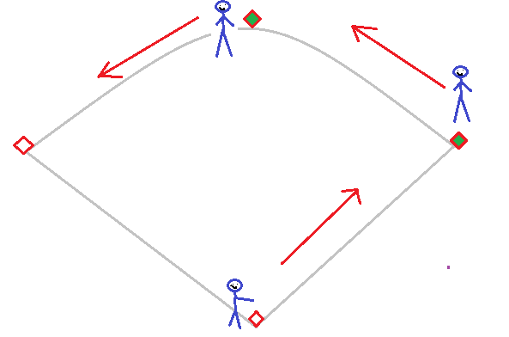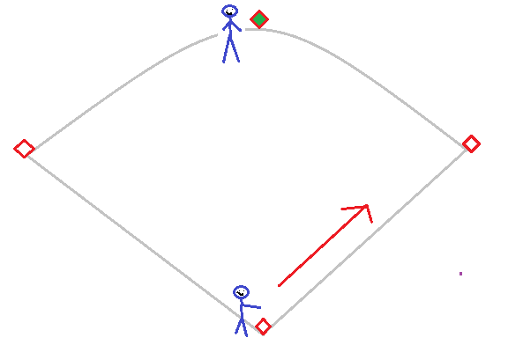
- Runner tries to runs to 3rd base throw down to 3rd.
Steal to Home Base
These are all the possible pictures when a runner will steal home. Do not throw to any other base when runners are in these situations.
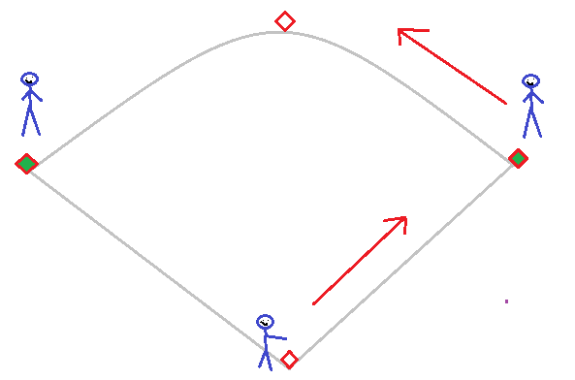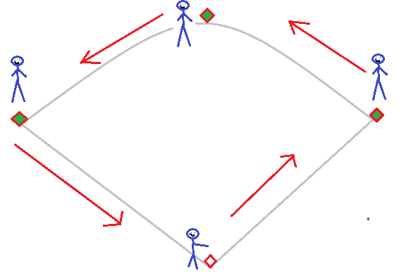
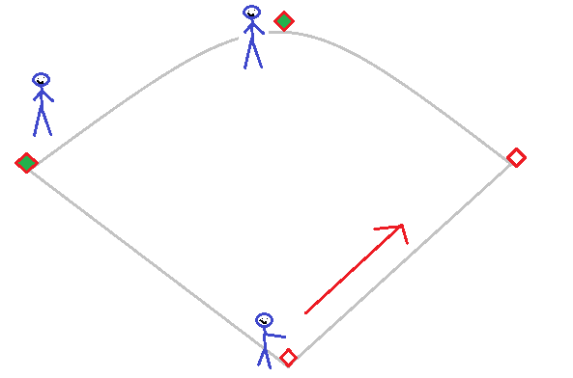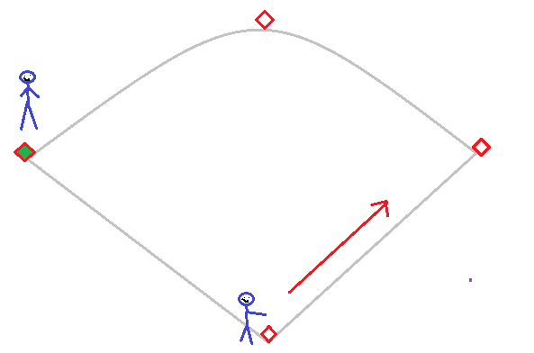

- If the runner on 3rd base is off the base a too much, immediately throw to 3rd base without hesitation. Plan this ahead and don’t delay, delay will kill a play. Do not pump throw or walk the runner back! If you pump throw or walk a runner back while there are other runners are on base they will steal on you because your focus is distracted.

